

PROJECT ENTITLED

**“HOUSING SOCIETY MANAGEMENT SYSTEM”**

SUBMITTED BY

***Mr. RITESH DHANDI***

UNDER THE GUIDANCE OF

***Mr. Abhijeet Salvi***

***Mrs. Shubhangi Pawar***

***Mrs. Sujatha Shahabade***

SUBMITTED IN PARTIAL FULFILLMENT OF THE

REQUIREMENTS FOR THE AWARD OF THE DEGREE OF

**BACHELOR IN COMPUTER SCIENCE**

**PILLAI COLLEGE OF ARTS, COMMMERCE AND**

**SCIENCE**

**(2018-2019)**

|  |  |
| --- | --- |
| **Sr. No.** | **Topic** |
| **1.** | **Acknowledgement** |
| **2.** | **Preliminary Investigation** |
|  | Introduction |
|  | Description of system |
|  | Limitation of present system |
|  | proposed system and its advantages |
|  | Feasibility study |
|  | Technologies used |
|  | Gantt chart |
| **3.** | **System Analysis and Design** |
|  | Fact Finding techniques |
|  | Event table |
|  | Use case diagram |
|  | Data Flow Diagram |
|  | ER Diagram |
|  | Activity diagram |
|  | Class Diagram |
|  | package diagram |
| **4.** | **System coding** |
|  | Sitemap |
|  | list of tables with attribute and constraint |
|  | Test cases,test data |
|  | Screen Layouts |
| **5.** | **Future enhancements** |
| **6.** | **Reference and Bibliography** |

**INDEX**

**ACKNOWLEDGEMENT**

I , **Master Ritesh Dhandi**, student of PILLAI COLLEGE OF ARTS,

COMMERCE & SCIENCE, NEW PANVEL would like to express my

sincere gratitude towards Computer Science Department.

I would like to thank Mrs. Deepika Sharma H.O.D. (I.T. & C.S.) for

granting me the opportunity to build project for the college. Last but not

least I thank Lect. ( Mr. Abhijeet Salvi, Mrs. Shubhangi Pawar,) for their constant support during the project.

The project would not have been completed without dedication, creativity and energy which my family provided.

Yours faithfully,

Ritesh Dhandi

(Final Year Computer Science)

**PRELIMINARY INVESTIGATION**

INTRODUCTION

* Generally, in Society all the work is decided in meetings and maintenance bills, contact no of members are recorded on the papers.
* There is no automated system for doing all the things that generally happens in society, so that members can come to know what is happening in society.
* The Society Management System allows members to login with their own account and get updated with society happenings. Society Management System is the website portal to reduce conflicts among society members.
* The system provides a unique interface to every user to interact with the system. System accepts queries from users and evaluates the need of the query and fires it over the database and results are displayed to the user.
* Admin can add member a details and manage complaints. He can add events and assign charges to the member. He can allot work to the staff.
* Members can view their accounts . They can view events and complain. Members can view the assigned maintanance.

**PROBLEM DEFINTION**

* As we all are aware of the current housing society management system which is handled manually.
* The data is stored in the files and the processing of the data is done manually and the report generation is slow. Data which is required cannot be accessed quickly.
* The data is stored in various registers so the linking between it becomes difficult.
* In this era, people are very busy with their routine work, so they do not have time for complaining about small problems related to society.
* The works are done manually which are slow and tiresome.
* Each house is visited for payments, messages, events and other related issues.
* It is very difficult to handle and manage flat owners data.
* There is no transparency and efficiency in working.

**OBJECTIVE**

* To help in managing and handling flat owners data.
* To help in managing society funds.
* To help in managing all events, complaints related to the society.
* To bring transparency and efficiency in the working of the society.
* To reduce conflicts among members.

**EXISTING SYSTEM**

* Existing system for a society is based on our traditional way keeping records and details on paper and registers.
* Access of these details and papers are not granted to common member in absence of the authority.
* Society chairman keep all the society expenses report on paper file. If some time this data is needed then retrieving this data is very slow and tiresome work. Society expenses and earning data is stored in various registers so the linking between it becomes difficult.
* Voting is conducted in the society for various designations like secretary, treasurer, chairman, etc. members need to be present on the site for voting. Due to some reasons some members cannot be present & cast vote.
* This problem needs to be solved so that all society member can take part in the voting.
* Generating bill and sending it to each society member is also a tiresome work. Sometimes, members do not get bills and it is lost. Payment collection is also big task in society. Watchman goes to each flat to collect the payments.
* In current system all work is done manually so each work takes more time. Sending notice or other message to society members is also a big task, so a system is needed that can solved all above problems.

**PROPOSED SYSTEM**

* **The main functionality of our project is that there is a management for different members,events and happenings of the society. Admin can add members individually using the admin module. Admin can add the information about the events ongoing in the society.**
* **This System allows members to login with their own account and get updated with society happenings.**
* **Admin can add, update or remove a member. He can publish the details of the events of the society.**
* **Admin can assign charges and calculate maintenance.**
* **Members can report complaints and provide solutions using the system interface.**
* **Members can view events and their maintainance charges.**
* **This system reduces conflicts amongst society members.**

**SCOPE**

* This project can be enhanced further by adding online payment facility for the members to reduce extra work of the admin.
* This system is flexible enough to be modified and implemented as per future requirements.
* Message and Email alerts for various happenings in the society can be added to the system.
* The system can be used by any housing organization .This system helps the organizer to store data in digital form.
* This system is free and user-friendly website to society members.

**REQUIREMENT ANALYSIS**

HARDWARE REQUIREMENTS:

* A Pentium 2/Pentium 3 equivalent or later processor.
* Display with more than 256-colors recommended.
* 256 MB of ram minimum.
* 80GB of Hard disk, but not much space will be used.
* Any 32-bit Windows Operating system.
* Keyboard and mouse will provide user friendly interaction between user and the system and the forms can be viewed through a monitor in GUI.

SOFTWARE REQUIREMENTS:

FRONT END:HTML, BOOTSTRAP,CSS

* HTML: It is the program that is used to create web pages and save HTML documents.
* BOOTSTRAP: It is a free and open source framework intend to design websites and web application.
* CSS: It is cascade style sheet used for designing the web page to make it more attractive.

BACK END:PHP, MySql

* PHP: It is a technology that allows software developers to create dynamically generated web pages in HTML, XML, or other document types, as per client request.
* MySql: It is a database, widely used for accessing, querying, updating and managing data in databases.

USER REQUIREMENTS:

* User should know that how the system is flowing.
* User should know the purpose of proposed system.
* User should know how to operate the system.

**SYSTEM MODULES**

This housing society management system has three main modules.

* Admin Module
* Member Module
* Admin: The admin is a person who runs and manages the entire system. The admin can add members and staff of the housing society and can delete or update their details. He can add events and manages them. He can view all the complaints made by the members. He can assign maintenance charges to the members. He can conduct voting for the positions in the society.

Admin Functionality:

* + Add Members
  + Add Charges
  + Calculate Maintainance
  + Add Events
  + View Complaints
  + Logout
* Member: All members have unique username and password to access the system. The members can view their details and manage their accounts. They can view events in the society. They can make complaints.

Member Functionality:

1. View Profile
2. Make Complain
3. View Maintainance
4. View Events
5. Logout

**FEASIBILITY STUDY**

A feasibility study is an analysis used in measuring the ability and likelihood to    complete a project successfully including all relevant factors. It must account for factors that affect it such as economic, technological, legal and scheduling factors. Project managers use feasibility studies to determine potential positive and negative outcomes of a project before investing a considerable amount of time and money into it.

1. **Technical Feasibility Study**

The engineering feasibility of the project in viewed in the technical feasibility. Certain important engineering aspects are covered which are necessary for the designing of the project like civil, structural and other relevant aspects. Technical capability of the projected technologies and the capabilities of the personnel to be employed in the project are considered. In certain examples especially when projects are in third world countries, technology transfer between cultures and geographical areas should be analyzed. By doing so productivity gain (or loss) and other implications are understood due to the differences in fuel availability, geography, topography, infrastructure support and other problems.

1. **Managerial Feasibility Study**

It considers the acceptability of the system and checks whether the system will be used if it is developed and implemented. The user will be able to handle the system easily, whether the system will cause any trouble. The user friendliness of the system result in simplicity of the operation. The long term benefit of the system would enhance the working style of the user.

.

1. **Economic Feasibility Study**

Economic feasibility refers to the feasibility of the considered project to produce economic benefits. A benefit-cost analysis is needed. Furthermore the economic feasibility of a project can also be evaluated by a breakeven analysis. In order to facilitate the consistent basis for the evaluation, the tangible and intangible facet of a project must be translated into the economic terms. Economic feasibility is critical even when the project is non-profit in nature

**GANTT CHART:**

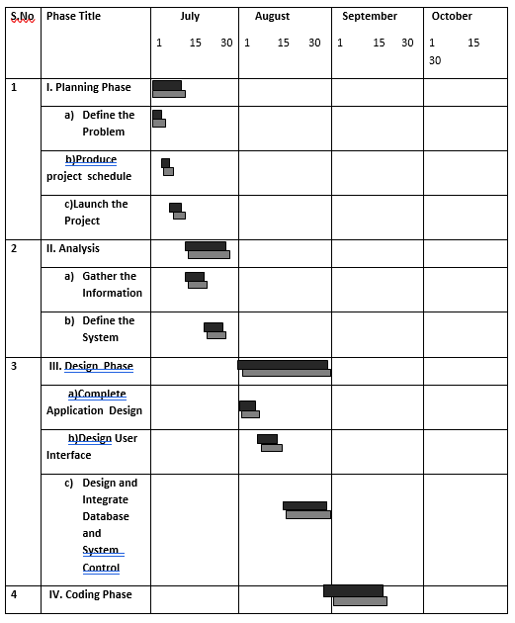

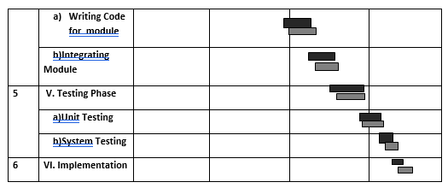

**SYSTEM ANALYSIS AND DESIGN**

FACT FINDING TECHNIQUES:

1.Onsite Observations:

Observations were done during the interview with the society head. It was very helpful us to understand how the society manages everything currently.

2.Review the Existing Documents:

Various type of documents such as maintenance bills, member details reports , event reports etc were collected.

3.Interviews:

We interview the society staff and some of the members of the process used to manage everything in the society and how it is done. In the interview some objectives are considered such as

1.Determining the areas to be discovered.

2.List the facts you want to gather.

**Questionaire**

A series of questions to be asked is called questionnaires.

1.How the society keep tracks of all the member details?

2. How the society manages all the events?

3. How the society manages all the members details?

4. How the maintenance is calculated and assigned to each member?

5. How the members get to know of all the events ongoing or upcoming in the society?

6. How members complaint in the society?

7.How the society manages all the complaints?

8. How maintenance bills are generated?

**EVENT TABLE**

|  |  |  |  |  |  |  |
| --- | --- | --- | --- | --- | --- | --- |
| **No.** | **Event** | **Trigger** | **Source** | **Activity** | **Response** | **Destination** |
| 1 | Login | User Click On Login | Admin/  Member | Login | Login Successful/Fail | admin panel/  member panel |
| 2 | Adding new  Member | Admin Fills The Member Details Form | admin | Add Member | Member Added Sucessfully/Unsucessfully | viewmemberdetails |
| 3 | Assigning The  Charges | Admin Clicks On The Add Charges Button | Admin | Add  Charges | Charges added successfully  /Unsuccessful | addcharges |
| 4 | View Maintanance | Admin clicks on search member button to view maintanance | Admin | View Maintanance | Maintanance Displayed | viewmaintanance |
| 5 | View Complaints | Admin clicks on view complaints | Admin | View Complaints | Compalints displayed | viewcomplaints |
| 6 | Adding  Events | Admin clicks on add event button | Admin | Events | Event added successfully/Unsuccessful | events |
| 7 | Update Profile | Member click s on update profile button | Member | Member Profile | Member Profile Updated successfully/Unsuccesfull | Member panel |

|  |  |  |  |  |  |  |
| --- | --- | --- | --- | --- | --- | --- |
| 8 | View Events | Member clicks on view event | Member | View Events | Events displayed | View events |
| 9 | Change Password | Member Clicks On Change Password Button | Member | Change Password | Password Change Successful/Unsuccessful | Member panel |
| 10 | My  Maintanance | Member Clicks On My Maintainance | Member | Members Maintanance | Maintanance  displayed | Member maintanance |
| 11. | Complaint | Member clicks on add complaint button | Member | Add  Complaint | Complaint added successfully/unsuccessful | complaints |
| 12. | Create  bill | Member clicks on create pdf button | member | Bill | Bill Generated | bill |
| 13. | Search | Admin Enters The Required Details To Search A Record And Clicks On Button | Admin | Search | Display Search Result | module specific |

**DATA FLOW DIAGRAM(DFD):**

* Level 0

HOUSING SOCIETY MANAGEMENT SYSTEM

USER

USER

**U**

* Level 1

ADMIN

USER

MEMBER

USER

MEMBER

MEMBER

MEMBER

MEMBER

* Level 2:

ADMIN

MEMBER

* Level 2:

MEMBER

MEMBER

USE-CASE DIAGRAM

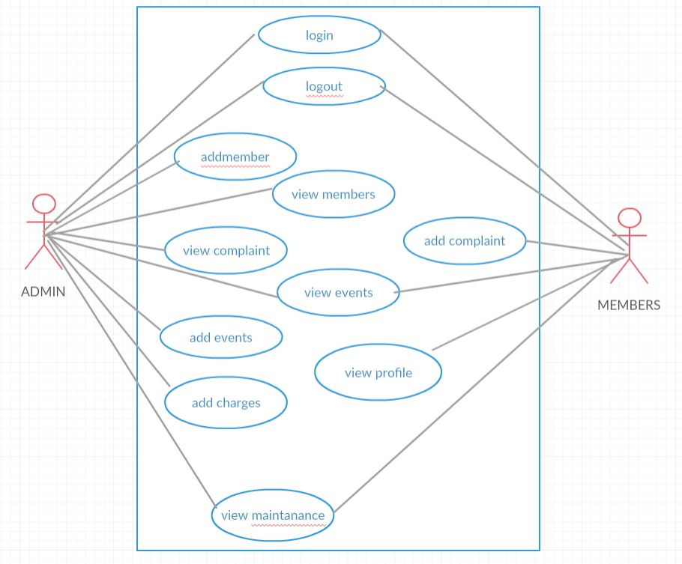

ER DIAGRAM:

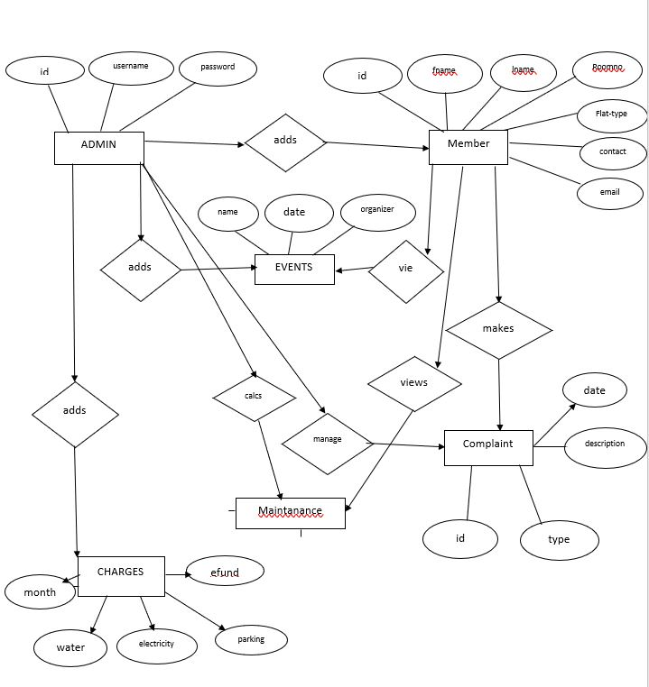

CLASS DIAGRAM

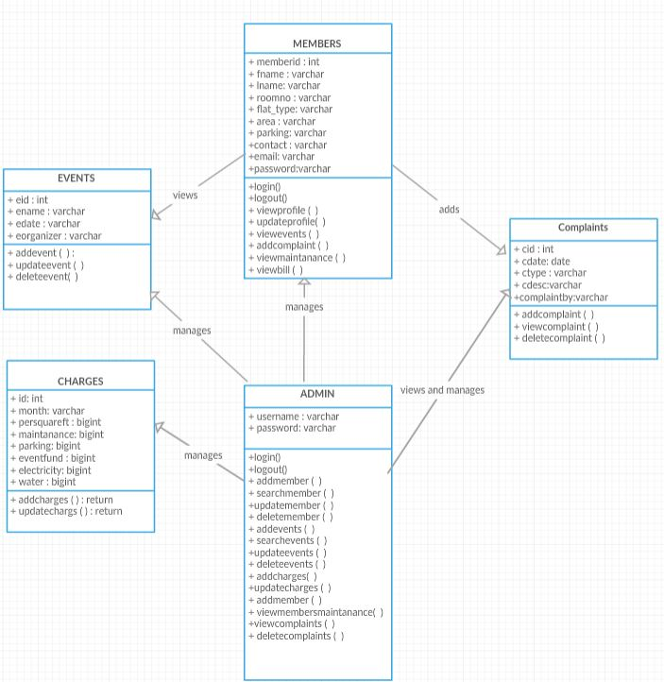

ACTIVITY DIAGRAM

FOR MEMBERS:

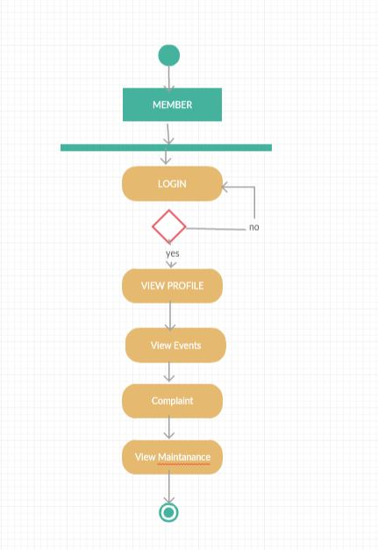

FOR ADMIN:

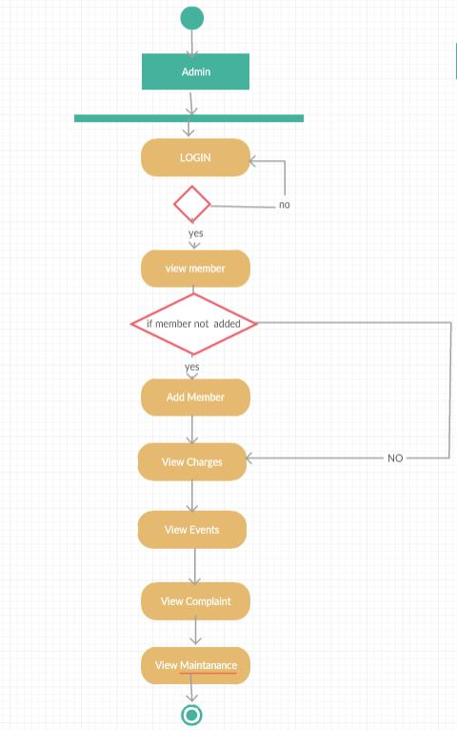

**PACKAGE DIAGRAM**

CHARGES

ADMIN

MAINTANANCE

EVENTS

COMPLAINT

MEMBER

**SYSTEM CODING**

SITEMAPS

1.FOR ADMIN:

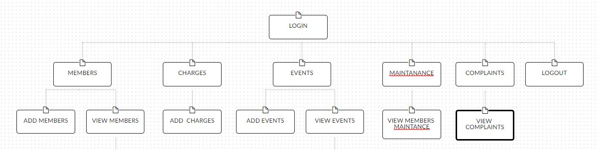

2.FOR MEMBERS:

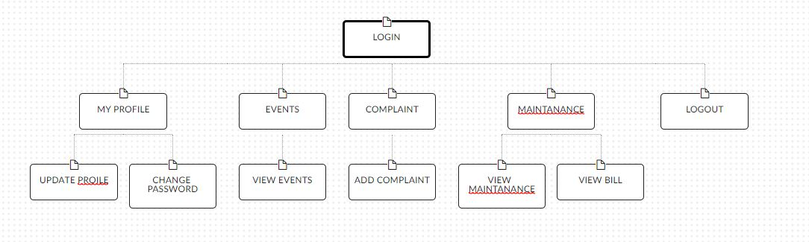

**DATABASE TABLES WITH ATTRIBUTES**

charges Table:

|  |  |  |  |
| --- | --- | --- | --- |
| Name | Type | Size | Description |
| id(primary key) | Int | 5 | Charges id |
| month | varchar | 50 | Month |
| persquareft | BigInt | 5 | Charge per square ft |
| maintanance | BigInt | 5 | Maintenance charge |
| parking | BigInt | 5 | Parking charge |
| eventfund | BigInt | 5 | Event charges |
| water | BigInt | 5 | Water charges |
| electricity | BigInt | 5 | Electricity charges |

events Table:

|  |  |  |  |
| --- | --- | --- | --- |
| Name | Type | Size | Description |
| eid(primary key) | Int | 15 | Event id |
| ename | varchar | 50 | Event name |
| edate | date |  | Event date |
| eorganizer | varchar | 50 | Event organizer |

complaint Table:

|  |  |  |  |
| --- | --- | --- | --- |
| Name | Type | Size | Description |
| cid(primary key) | int | 15 | Complaint id |
| cdate | date |  | Complaint date |
| type | varchar | 50 | Complaint type |
| cdescription | varchar | 300 | Complaint description |
| complaintby | varchar | 15 | Complaint by |

addmember Table:

|  |  |  |  |
| --- | --- | --- | --- |
| Name | Type | Size | Description |
| Membered(primary key) | int | 5 | Member id |
| fname | varchar | 50 | First name |
| lname | varchar | 50 | Last name |
| roomno | varchar | 50 | Room no |
| Flat_type | varchar | 50 | Flat Type |
| area | varchar | 50 | Area in square ft |
| parking | varchar | 50 | Has parking? |
| contactno | varchar | 50 | Contact No |
| email | varchar | 50 | Email |
| password | varchar | 50 | Password |

**TEST CASES, TEST DATA AND TEST RESULT**

|  |  |  |  |  |  |
| --- | --- | --- | --- | --- | --- |
| **Testid** | **Test Case** | **Test Data** | **Expected Result** | **Actual**  **Outcome** | **Status** |
|  | **LOGIN FORM** | | | | |
| 1. | 1.Enter Room NO  2.Enter password  3.Click ’login’ | 102  Ritesh@123 | Open the member profile page | Open the member profile page | Pass |
| 2. | 1.Enter Room No  2.Enter password  3.Click ’login’ | 105  xyz123 | Enter Correct  Details | Enter Correct Details | Pass |
| 3. | 1.Enter Room No  2.Enter password  3.Click ’login’ | 123  abc123 | Enter Correct  Details | Enter Correct  Details | Pass |
| 4. | 1.Enter Room No  2.Enter password  3.Click ’login’ | null  null | Please Fill roomno and password | Please fill roomno and password | Pass |
|  | **ADD MEMBER FORM** | | | | |
| 1. | 1.Enter First Name  2.Enter Last name  3.Enter Roomno  4.Enter Flat Type  5.Enter Area per square ft  6.Enter Parking  6.Enter contact no.  7.Enter email  8.Enter Password  9.Confirm password:  .10.Click on ADD | Ritesh  Dhandi  101  1BHK  800  Yes  8745123650  rtshdhandi@gmail.com  rit1223  rit1223 | Member added successfully | Member  Added Successfully | Pass |

|  |  |  |  |  |  |  |  |  |  |
| --- | --- | --- | --- | --- | --- | --- | --- | --- | --- |
| ` | | 1.Enter First Name  2.Enter Last name  3.Enter Roomno  4.Enter Flat Type  5.Enter Area per square ft  6.Enter Parking  6.Enter contact no.  7.Enter email  . 8.Enter Password  9.Confirm password:  .10.Click on ADD | null  null  null  null  null  null  null  null  null  null  null | | | Please fill out this field | | Please fill out this field | Pass |
| 3. | 1.Enter First Name  2.Enter Last name  3.Enter Roomno  4.Enter Flat Type  5.Enter Area per square ft  6.Enter Parking  6.Enter contact no.  7.Enter email  8.Enter Password  9.Confirm password:  .10.Click on ADD | | | Ritesh  Dhandi  101  1BHK  800  Yes  8745123650  rtshdhandi@gmail.com  rit12  rit12 | Room No Already  Added | | Room No Already Added | | Pass |
|  | **ADD EVENT FORM** | | | | | | | | |
| 1. | 1.Enter Event Name  2.Enter Event Date  3.Enter Event Organizer  4.Click on ADD | | | Janmashtami  18-08-2018  102 | Event Added | | Event Added | | Pass |
| 2. | 1.Enter Event Name  2.Enter Event Date  3.Enter Event Organizer  4.Click on ADD | | | null  20-09-2018  null | Please fill out the fields | | Please fill out these fields | | Pass |
|  | **CHARGES FORM** | | | | | | | | |
| 1. | 1.Enter Month  2.Enter Per Square Ft Charge  3.Enter maintenance Charge  4.Enter parking Charge  5.Enter Event Fund  6.Enter Electricity Charge  7.Enter Water Charge  8.Click on submit | | | OCTOBER  10  440  300  600  600  500 | Charges Updated | | Charges Updated | | Pass |
| 2. | 1.Enter Month  2.Enter Per Square Ft Charge  3.Enter maintenance Charge  4.Enter parking Charge  5.Enter Event Fund  6.Enter Electricity Charge  7.Enter Water Charge  8.Click on submit | | | null  null  null  null  null  null  null | Please fill out these fields | | Please fill out these fields | | Pass |
|  | **COMPLAINT REGISTERATION FORM** | | | | | | | | |
| 1. | 1.Enter Complaint Date  2.Enter Complaint Type  3.Enter Complaint | | | 16-09-2018  Parking  Parking Complaint | Complaint registered successfully | | Complaint registered  successfully | | Pass |
| 2. | 1.Enter Complaint Date  2.Enter Complaint Type  3.Enter Complaint | | | 18-09-2018  Null  Null | Please fill out the field | | Please fill out the field | | Pass |

**SCREEN LAYOUTS AND REPORTS**

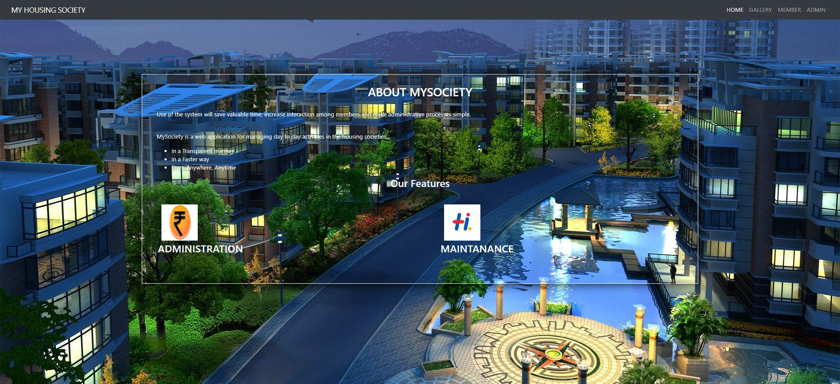

index.php

<!DOCTYPE html>

<html >

<head>

<link rel="stylesheet" href="https://stackpath.bootstrapcdn.com/bootstrap/4.1.3/css/bootstrap.min.css" integrity="sha384-MCw98/SFnGE8fJT3GXwEOngsV7Zt27NXFoaoApmYm81iuXoPkFOJwJ8ERdknLPMO" crossorigin="anonymous">

<link href="css/global.css" type="text/css" rel=" stylesheet" >

</head>

<body style="background:url('images/8.jpg') no-repeat; background-size:cover;">

<nav class="navbar navbar-expand-sm bg-dark navbar-dark">

<div class="container-fluid" >

<a class="navbar-brand" href="">MY HOUSING SOCIETY</a>

<nav class="nav navbar-nav">

<ul class="nav navbar-nav navbar-right">

<li class="nav-item ">

<a class="nav-link active" href="">HOME</a>

</li>

<li class="nav-item">

<a class="nav-link" href="gallery2.php">GALLERY</a>

</li>

<li class="nav-item">

<a class="nav-link " href="members.php">MEMBER </a>

</li>

<li class="nav-item">

<a class="nav-link " href="admin.php">ADMIN </a>

</li>

</ul>

</nav>

</div>

</nav>

<div class="row">

<div class="col-md-2"></div>

<div class="col-md-8">

<form class="form-container">

<div id="content">

<h2 align="center"> ABOUT MYSOCIETY </h2><br>

<p>Use of the system will save valuable time, increase interaction among members and make administrative processes simple. </p><br>

<p> MySociety is a web application for managing day to day activities in the housing societies... </p>

<ul>

<li>In a Transparent manner</li>

<li>In a Faster way</li>

<li>From Anywhere, Anytime</li>

</ul>

<h3 align="center">Our Features<h3><br>

<table width="100%" border="0" cellspacing="3" cellpadding="3">

<tr>

</tr>

<tr>

<td><p><img src="images/13.jpg" alt="box" width="100" height="100" hspace="10" align="left" class="imgleft" title="box" /></p></td>

<td><p><img src="images/14.jpg" alt="box" width="100" height="100" hspace="10" align="left" class="imgleft" title="box" /></p></td>

</tr>

<tr>

<td bgcolor="">ADMINISTRATION</td>

<td bgcolor="">MAINTANANCE</td>

</tr>

</table>

<p>&nbsp;</p>

</div>

</form>

</div>

</div>

</div>

</div>

</div>

<script src="https://ajax.googleapis.com/ajax/libs/jquery/3.2.1/jquery.min.js"></script>

<script src="https://stackpath.bootstrapcdn.com/bootstrap/4.1.3/js/bootstrap.min.js" integrity="sha384-ChfqqxuZUCnJSK3+MXmPNIyE6ZbWh2IMqE241rYiqJxyMiZ6OW/JmZQ5stwEULTy" crossorigin="anonymous"></script>

</body>

</html>

dbcon.php

<?php

$con=mysqli_connect("localhost","root","","my");

if(isset($_POST['login_submit'])){

$username=$_POST['username'];

$password=$_POST['password'];

$query="select * from society where username='$username' and password='$password'";

$result=mysqli_query($con,$query);

if(mysqli_num_rows($result)==1)

{

session_start();

$_SESSION['username']=$_POST['username'];

header("Location:admin-panel.php");

}

else

{

echo "<script>

window.location.href='admin.php';

alert('Enter Correct Details');

</script>";

}

}

if(isset($_POST['membersubmit']))

{

$chars = "abcdefghijklmnopqrstuvwxyzABCDEFGHIJKLMNOPQRSTUVWXYZ0123456789";

$password = substr( str_shuffle( $chars ), 0, 8 );

$fname=$_POST['fname'];

$lname=$_POST['lname'];

$roomno=$_POST['roomno'];

$flat_type=$_POST['flat_type'];

$area=$_POST['area'];

$parking=$_POST['parking'];

$contactno=$_POST['contactno'];

$email=$_POST['email'];

$query1 = $con->query("SELECT * FROM `addmember` WHERE `roomno` = '$roomno'");

$check = $query1->num_rows;

if($check == 1)

{

echo "<script>alert('RoomNO Has Already Been Added')</script>";

}

else{

$con->query ("insert into addmember (fname,lname,roomno,flat_type,area,parking,contactno,email,password)values('$fname','$lname','$roomno','$flat_type','$area','$parking','$contactno','$email','$password')")

or die(mysqli_error());

echo "<script>

window.location.href='admin-panel.php';

alert('member added');

</script>";

}

}

if(isset($_POST['eventsubmit']))

{

$ename=$_POST['ename'];

$edate=$_POST['edate'];

$eorganizer=$_POST['eorganizer'];

$query="insert into events (ename,edate,eorganizer)values('$ename','$edate','$eorganizer')";

$result=mysqli_query($con,$query);

if($result)

{

echo "<script>alert('Event added')</script>";

echo "<script>window.open('events.php','_self')</script>";

}

else

{

echo "<script>alert('Event Not added')</script>";

echo "<script>window.open('events.php','_self')</script>";

}

}

?>

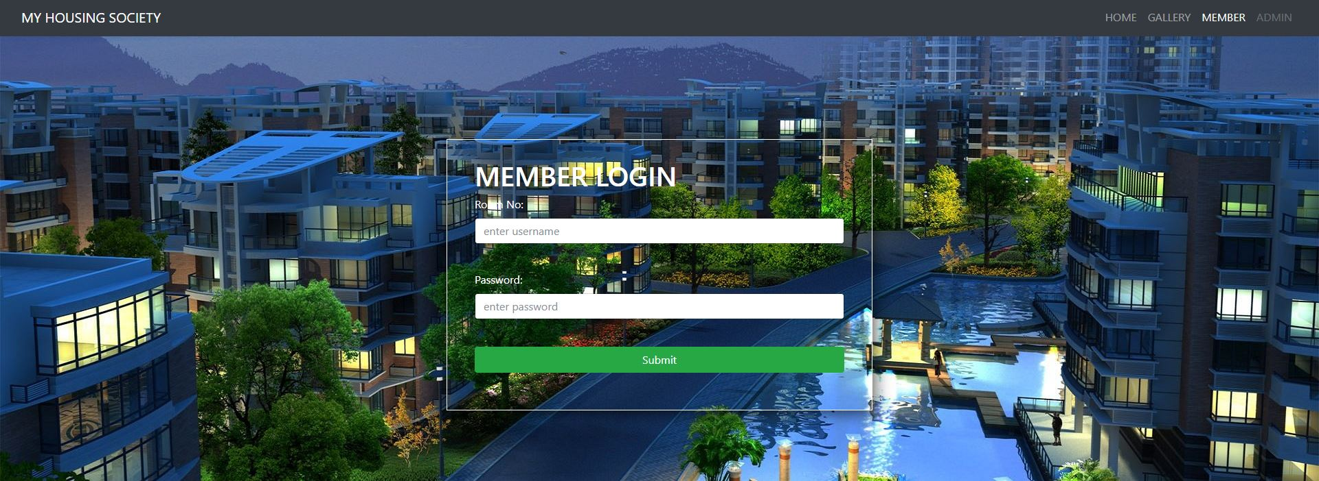

members.php

<html >

<head>

<link rel="stylesheet" type="text/css" href="https://maxcdn.bootstrapcdn.com/bootstrap/4.0.0-beta/css/bootstrap.min.css" integrity="sha384-/Y6pD6FV/Vv2HJnA6t+vslU6fwYXjCFtcEpHbNJ0lyAFsXTsjBbfaDjzALeQsN6M" crossorigin="anonymous">

<link href="css/global.css" type="text/css" rel=" stylesheet" >

</head>

<body style="background:url('images/8.jpg') no-repeat; background-size:cover;">

<nav class="navbar navbar-expand-sm bg-dark navbar-dark">

<div class="container-fluid" >

<a class="navbar-brand" href="">MY HOUSING SOCIETY</a>

<nav class="nav navbar-nav">

<ul class="nav navbar-nav navbar-right">

<li class="nav-item ">

<a class="nav-link" href="index.php">HOME</a> </li>

<li class="nav-item">

<a class="nav-link" href="gallery2.php">GALLERY</a> </li>

<li class="nav-item">

<a class="nav-link active " href="members.php">MEMBER </a> </li>

<li class="nav-item">

<a class="nav-link disabled" href="admin.php">ADMIN </a> </li>

</ul> </nav> </div></nav>

<div class="row">

<div class="col-md-4"></div>

<div class="col-md-4">

<form class="form-container";" method="post" action="membercon.php"><h1>MEMBER LOGIN</h1>

<div class="form-group">

<label>Room No: </label><br>

<input type="text" name="username" class="form-control" placeholder="enter username" required ><br>

</div>

<div class="form-group">

<label>Password: </label>

<input type="password" class="form-control" name="password" placeholder="enter password" required ><br>

</div>

<input type="submit" name="login_submit" class="btn btn-success btn-block"><br>

</form>

</div></div></div>

<script src="https://ajax.googleapis.com/ajax/libs/jquery/3.2.1/jquery.min.js"></script>

<script src="https://maxcdn.bootstrapcdn.com/bootstrap/4.0.0-beta/js/bootstrap.min.js" integrity="sha384-h0AbiXch4ZDo7tp9hKZ4TsHbi047NrKGLO3SEJAg45jXxnGIfYzk4Si90RDIqNm1" crossorigin="anonymous"></script>

</body>

</html>

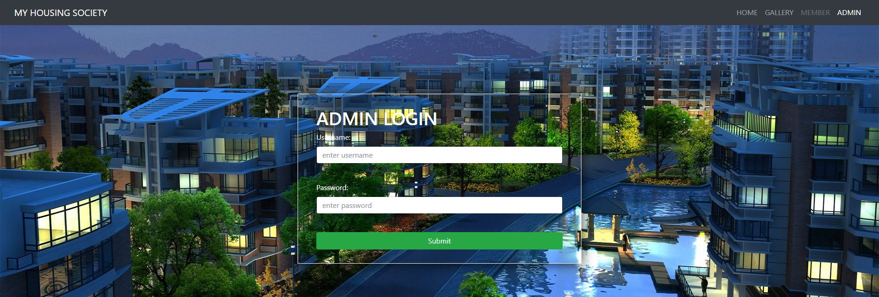

admin.php

<!DOCTYPE html>

<html >

<head>

<link rel="stylesheet" type="text/css" href="https://maxcdn.bootstrapcdn.com/bootstrap/4.0.0-beta/css/bootstrap.min.css" integrity="sha384-/Y6pD6FV/Vv2HJnA6t+vslU6fwYXjCFtcEpHbNJ0lyAFsXTsjBbfaDjzALeQsN6M" crossorigin="anonymous">

<link href="css/global.css" type="text/css" rel=" stylesheet" >

</head>

<body style="background:url('images/8.jpg') no-repeat; background-size:cover;">

<nav class="navbar navbar-expand-sm bg-dark navbar-dark">

<div class="container-fluid" >

<a class="navbar-brand" href="">MY HOUSING SOCIETY</a>

<nav class="nav navbar-nav">

<ul class="nav navbar-nav navbar-right">

<li class="nav-item ">

<a class="nav-link" href="index.php">HOME</a>

</li>

<li class="nav-item">

<a class="nav-link" href="gallery2.php">GALLERY</a>

</li>

<li class="nav-item">

<a class="nav-link disabled " href="members.php">MEMBER </a>

</li>

<li class="nav-item">

<a class="nav-link active" href="admin.php">ADMIN </a>

</li>

</ul>

</nav>

</div>

</nav>

<div class="row">

<div class="col-md-4"></div>

<div class="col-md-4">

<form class="form-container" method="post" action="dbcon.php">

<h1 > ADMIN LOGIN</h1>

<div class="form-group">

<label>Username: </label><br>

<input type="text" name="username" class="form-control" placeholder="enter username" required ><br>

</div>

<div class="form-group">

<label>Password: </label>

<input type="password" class="form-control" name="password" placeholder="enter password" required ><br>

</div>

<input type="submit" name="login_submit" class="btn btn-success btn-block">

</form>

</div>

</div>

</div>

<script src="https://ajax.googleapis.com/ajax/libs/jquery/3.2.1/jquery.min.js"></script>

<script src="https://maxcdn.bootstrapcdn.com/bootstrap/4.0.0-beta/js/bootstrap.min.js" integrity="sha384-h0AbiXch4ZDo7tp9hKZ4TsHbi047NrKGLO3SEJAg45jXxnGIfYzk4Si90RDIqNm1" crossorigin="anonymous"></script>

</body>

</html>

ADMIN

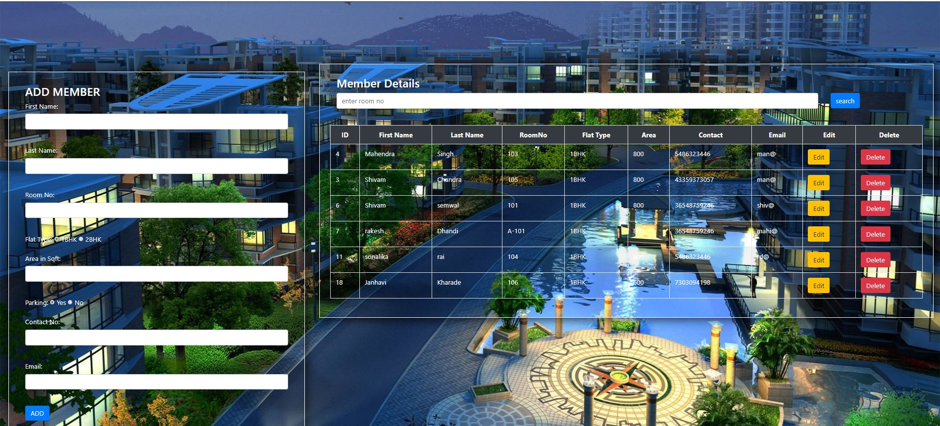

admin-panel.php

<?php include("dbcon.php");?>

<html>

<head>

<title></title>

<link rel="stylesheet" href="https://stackpath.bootstrapcdn.com/bootstrap/4.1.3/css/bootstrap.min.css" integrity="sha384-MCw98/SFnGE8fJT3GXwEOngsV7Zt27NXFoaoApmYm81iuXoPkFOJwJ8ERdknLPMO" crossorigin="anonymous">

<link href="css/global.css" type="text/css" rel=" stylesheet" >

</head>

<body style="background:url('images/8.jpg') no-repeat; background-size:cover;">

<nav class="navbar navbar-expand-sm bg-dark navbar-dark">

<div class="container-fluid">

<a class="navbar-brand" href="">ADMIN DASH</a>

<nav class="nav navbar-nav">

<ul class="nav navbar-nav navbar-right">

<li class="nav-item active">

<a class="nav-link" href="admin-panel.php">MEMBER</a>

</li>

<li class="nav-item">

<a class="nav-link" href="charges.php">ADD CHARGES</a>

</li>

<li class="nav-item">

<a class="nav-link disabled" href="events.php">EVENTS</a>

</li>

<li class="nav-item">

<a class="nav-link " href="viewcomplaints.php"> COMPLAINTS</a>

</li>

<li class="nav-item">

<a class="nav-link " href="maintanance.php"> MAINTANANCE</a>

</li>

<li class="nav-item">

<a class="nav-link " href="admin_logout.php"> LOGOUT</a>

</li>

</ul>

</nav>

</div>

</nav>

<?php

session_start();

if(isset($_SESSION['username'])) {

}

else

{

header("location: admin.php");

}

?>

<div class="container-fluid">

<div class="row">

<div class="col-md-4">

<div class="row">

<div class="card-body" >

<form class="form-container" action="" method="POST">

<h3 > ADD MEMBER</h3>

<div class="form-group">

<label>First Name:</label>

<input type="text" name="fname" class="form-control" required><br>

</div>

<div class="form-group">

<label>Last Name:</label>

<input type="text" name="lname" class="form-control"required><br>

</div>

<div class="form-group">

<label>Room No:</label>

<input type="text" name="roomno" class="form-control" required><br>

</div>

<div class="form-group">

<label>Flat Type: </label>

<input type="radio" name="flat_type" value="1BHK" checked> 1BHK

<input type="radio" name="flat_type" value="2BHK"> 2BHK<br>

</div>

<div class="form-group">

<label>Area in Sqft:</label>

<input type="text" name="area" class="form-control required"><br>

</div>

<div class="form-group">

<label>Parking: </label>

<input type="radio" name="parking" value="Yes" checked> Yes

<input type="radio" name="parking" value="No"> No<br>

</div>

<div class="form-group">

<label>Contact No:</label>

<input type="text" name="contactno" class="form-control" required><br>

</div>

<div class="form-group">

<label>Email:</label>

<input type="text" name="email" class="form-control" required><br>

</div>

<input type="submit" name="membersubmit" value="ADD" class="btn btn-primary">

<br>

</form>

</form>

</div>

</div>

</div>

<div class="col-md-8">

<form class="form-container" action="member_search.php" method="POST">

<h3> Member Details</h3>

<div class="row">

<div class="col-md-10"><input type="text" name="search" class="form-control" placeholder="enter room no"></div>

<div class="col-md-2"><input type="submit"value=" search" name="membersearch" class="btn btn-primary"></div><div class="card-body"></div>

<table class="table table-striped table-hover table-bordered">

<thead>

<tr class="bg-dark text-white text-center">

<th>ID</th>

<th>First Name</th>

<th>Last Name</th>

<th>RoomNo</th>

<th>Flat Type</th>

<th>Area</th>

<th>Contact</th>

<th>Email</th>

<th>Edit</th>

<th>Delete</th>

</tr>

</thead>

<tbody>

<?php

$query="Select * from addmember ";

$result=mysqli_query($con,$query);

while ($row=mysqli_fetch_array($result)){

?><tr>

<td><?php echo $row['memberid'] ?></td>

<td><?php echo $row['fname'] ?></td>

<td><?php echo $row['lname'] ?></td>

<td><?php echo $row['roomno'] ?></td>

<td><?php echo $row['flat_type'] ?></td>

<td><?php echo $row['area'] ?></td>

<td><?php echo $row['contactno'] ?></td>

<td><?php echo $row['email'] ?></td>

<td><a href="member_edit.php?idd=<?php echo $row['memberid'] ?>" class="btn btn-warning">Edit</a></td>

<td><a onclick="return confirm('Are you sure?')" href="admin-panel.php?idd=<?php echo $row['memberid'] ?>" class="btn btn-danger">Delete</a></td>

</tr>

<?php

if (isset($_GET['idd'])){

$idd=$_GET['idd'];

$query="Delete from addmember where memberid='$idd'";

$result=mysqli_query($con,$query);

if($result){

echo"<script>alert('Member deleted')</script>";

echo "<script>window.open('admin-panel.php','_self')</script>";

}

else{

echo"<script>alert('Failed')</script>";

echo "<script>window.open('admin-panel.php','_self')</script>";

}

}

?>

<?php

}

?>

</tbody>

</table>

</div>

</div>

<script src="https://ajax.googleapi.com/ajax/libs/jquery/3.2.1/jquery.min.js"></script>

<script src="https://stackpath.bootstrapcdn.com/bootstrap/4.1.3/js/bootstrap.min.js" integrity="sha384-ChfqqxuZUCnJSK3+MXmPNIyE6ZbWh2IMqE241rYiqJxyMiZ6OW/JmZQ5stwEULTy" crossorigin="anonymous"></script>

</body>

</html>

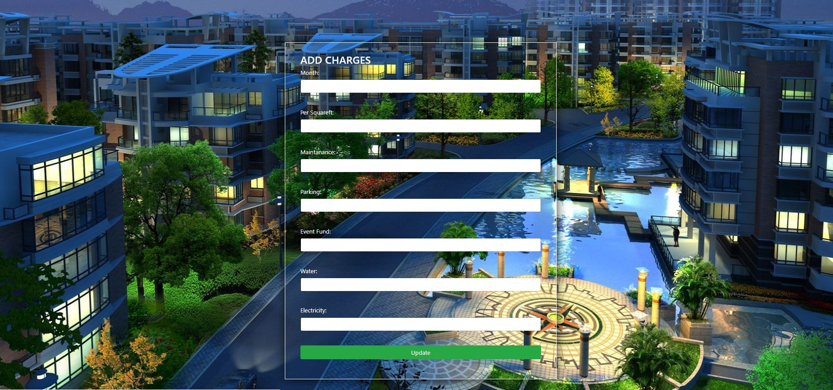

charges.php

<html>

<head>

<title></title> <link rel="stylesheet" href="https://maxcdn.bootstrapcdn.com/bootstrap/4.0.0-beta/css/bootstrap.min.css" integrity="sha384-/Y6pD6FV/Vv2HJnA6t+vslU6fwYXjCFtcEpHbNJ0lyAFsXTsjBbfaDjzALeQsN6M" crossorigin="anonymous">

<link href="css/global.css" type="text/css" rel=" stylesheet" >

</head>

<body style="background:url('images/8.jpg') no-repeat; background-size:cover;">

<nav class="navbar navbar-expand-sm bg-dark navbar-dark">

<div class="container-fluid">

<a class="navbar-brand" href="">ADMIN DASH</a>

<nav class="nav navbar-nav">

<ul class="nav navbar-nav navbar-right">

<li class="nav-item ">

<a class="nav-link" href="admin-panel.php">MEMBER</a>

</li>

<li class="nav-item active">

<a class="nav-link " href="charges.php">ADD CHARGES</a>

</li>

<li class="nav-item">

<a class="nav-link disabled" href="events.php">EVENTS</a>

</li>

<li class="nav-item">

<a class="nav-link " href="viewcomplaints.php"> COMPLAINTS</a>

</li>

<li class="nav-item">

<a class="nav-link " href="maintanance.php"> MAINTANANCE</a>

</li>

<li class="nav-item">

<a class="nav-link " href="admin_logout.php"> LOGOUT</a>

</li>

</ul>

</nav>

</div>

</nav>

<?php

session_start();

if(isset($_SESSION['username'])) {

}

else

{

header("location: admin.php");

}

?>

<div class="row">

<div class="col-md-4"></div>

<div class="col-md-4">

<div class="row">

<div class="card-body" >

<form class="form-container" action="addcharges.php" method="POST">

<h3 > ADD CHARGES</h3>

<div class="form-group">

<label>Month:</label>

<input type="text" name="month" class="form-control"><br>

</div>

<div class="form-group">

<label>Per Squareft:</label>

<input type="number" name="persquareft" class="form-control"><br>

</div>

<div class="form-group">

<label>Maintanance:</label>

<input type="number" name="maintanance" class="form-control"><br>

</div>

<div class="form-group">

<label>Parking:</label>

<input type="number" name="parking" class="form-control"><br>

</div>

<div class="form-group">

<label>Event Fund:</label>

<input type="number" name="eventfund" class="form-control"><br>

</div>

<div class="form-group">

<label>Water:</label>

<input type="number" name="water" class="form-control"><br>

</div>

<div class="form-group">

<label>Electricity:</label>

<input type="number" name="electricity" class="form-control"><br>

</div>

<input type="submit" name="chargesupdate" value="Update" class="btn btn-success btn-block">

<br>

</form>

</div>

</div>

</div>

</tbody>

</table>

</div>

</div>

<script src="https://ajax.googleapi.com/ajax/libs/jquery/3.2.1/jquery.min.js"></script>

<script src="https://maxcdn.bootstrapcdn.com/bootstrap/4.0.0-beta/js/bootstrap.min.js" integrity="sha384-h0AbiXch4ZDo7tp9hKZ4TsHbi047NrKGLO3SEJAg45jXxnGIfYzk4Si90RDIqNm1" crossorigin="anonymous"></script>

</body>

</html>

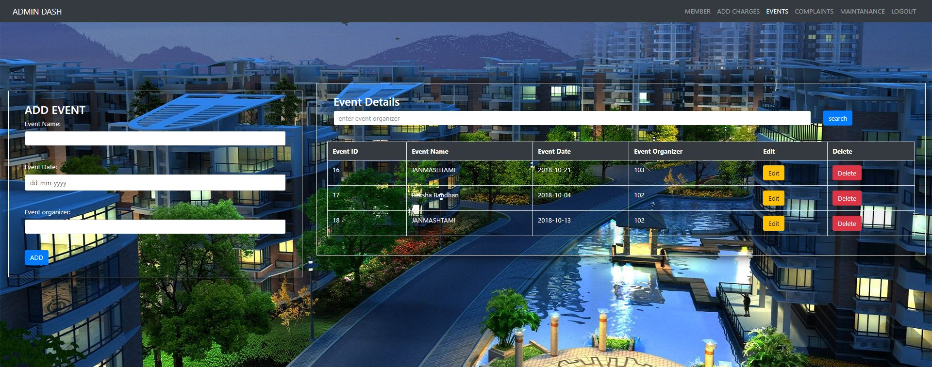

events.php

<?php

include('dbcon.php');

?>

<html>

<head>

<title></title> <link rel="stylesheet" href="https://maxcdn.bootstrapcdn.com/bootstrap/4.0.0-beta/css/bootstrap.min.css" integrity="sha384-/Y6pD6FV/Vv2HJnA6t+vslU6fwYXjCFtcEpHbNJ0lyAFsXTsjBbfaDjzALeQsN6M" crossorigin="anonymous">

<link href="css/global.css" type="text/css" rel=" stylesheet" >

</head>

<body style="background:url('images/8.jpg') no-repeat; background-size:cover;">

<nav class="navbar navbar-expand-sm bg-dark navbar-dark">

<div class="container-fluid">

<a class="navbar-brand" href="">ADMIN DASH</a>

<nav class="nav navbar-nav">

<ul class="nav navbar-nav navbar-right">

<li class="nav-item ">

<a class="nav-link" href="admin-panel.php">MEMBER</a>

</li>

<li class="nav-item ">

<a class="nav-link" href="charges.php">ADD CHARGES</a>

</li>

<li class="nav-item active">

<a class="nav-link " href="events.php">EVENTS</a>

</li>

<li class="nav-item">

<a class="nav-link " href="viewcomplaints.php"> COMPLAINTS</a>

</li>

<li class="nav-item">

<a class="nav-link " href="maintanance.php"> MAINTANANCE</a>

</li>

<li class="nav-item">

<a class="nav-link " href="admin_logout.php"> LOGOUT</a>

</li>

</ul>

</nav>

</div>

</nav>

<?php

session_start();

if(isset($_SESSION['username'])) {

}

else

{

header("location: admin.php");

}

?>

<div class="container-fluid">

<div class="row">

<div class="col-md-4">

<div class="row">

<div class="card-body" >

<form class="form-container" action="dbcon.php" method="POST">

<h3 > ADD EVENT</h3>

<div class="form-group">

<label>Event Name:</label>

<input type="text" name="ename" class="form-control"><br>

</div>

<div class="form-group">

<label>Event Date:</label>

<input type="date" name="edate" class="form-control"><br>

</div>

<div class="form-group">

<label>Event organizer:</label>

<input type="text" name="eorganizer" class="form-control"><br>

</div>

<input type="submit" name="eventsubmit" value="ADD" class="btn btn-primary">

<br>

</form>

</div>

</div>

</div>

<div class="col-md-8">

<form class="form-container" action="event_search.php" method="POST">

<h3> Event Details</h3>

<div class="row">

<div class="col-md-10"><input type="text" name="search" class="form-control" placeholder="enter event organizer"></div>

<div class="col-md-2"><input type="submit"value=" search" name="eventsearch" class="btn btn-primary"></div><div class="card-body"></div>

<table class="table table-striped table-hover table-bordered">

<thead>

<tr class="bg-dark text-white text-center">

<th>Event ID</th>

<th>Event Name</th>

<th>Event Date</th>

<th>Event Organizer</th>

<th>Edit</th>

<th>Delete</th>

</tr>

</thead><tbody>

<?php

$query="Select * from events ";

$result=mysqli_query($con,$query);

while ($row=mysqli_fetch_array($result)){

?><tr>

<td><?php echo $row['eid'] ?></td>

<td><?php echo $row['ename'] ?></td>

<td><?php echo $row['edate'] ?></td>

<td><?php echo $row['eorganizer'] ?></td>

<td><a href="event_edit.php?idd=<?php echo $row['eid'] ?>" class="btn btn-warning">Edit</a></td>

<td><a onclick="return confirm('Are you sure?')" href="events.php?idd=<?php echo $row['eid'] ?>" class="btn btn-danger">Delete</a></td>

</tr>

<?php

if (isset($_GET['idd'])){

$idd=$_GET['idd'];

$query="Delete from events where eid='$idd'";

$result=mysqli_query($con,$query);

if($result){

echo"<script>alert('Event deleted')</script>";

echo "<script>window.open('events.php','_self')</script>";

}

else{

echo"<script>alert('Failed')</script>";

echo "<script>window.open('events.php','_self')</script>";

}

}

?>

<?php

}

?>

</tbody>

</table>

</div></div>

<script src="https://ajax.googleapi.com/ajax/libs/jquery/3.2.1/jquery.min.js"></script>

<script src="https://maxcdn.bootstrapcdn.com/bootstrap/4.0.0-beta/js/bootstrap.min.js" integrity="sha384-h0AbiXch4ZDo7tp9hKZ4TsHbi047NrKGLO3SEJAg45jXxnGIfYzk4Si90RDIqNm1" crossorigin="anonymous"></script>

</body>

</html>

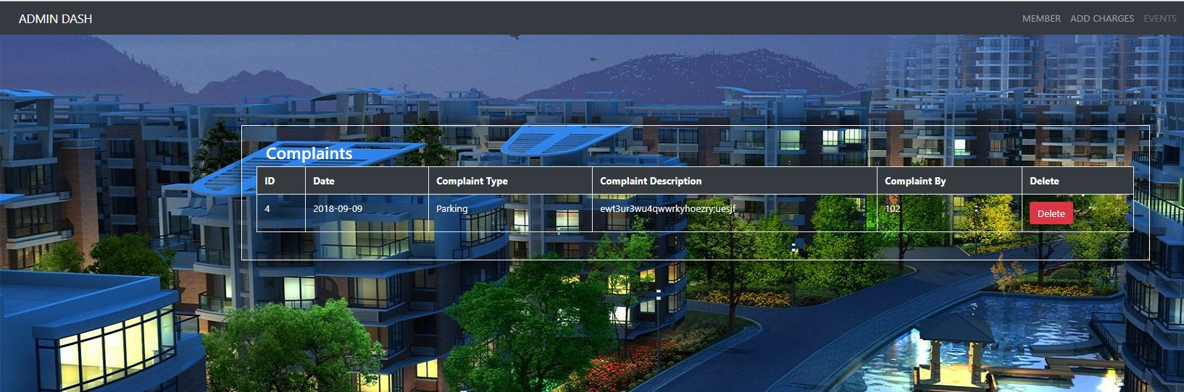

viewcomplaints.php

<?php include("dbcon.php");?>

<html>

<head>

<title></title> <link rel="stylesheet" href="https://maxcdn.bootstrapcdn.com/bootstrap/4.0.0-beta/css/bootstrap.min.css" integrity="sha384-/Y6pD6FV/Vv2HJnA6t+vslU6fwYXjCFtcEpHbNJ0lyAFsXTsjBbfaDjzALeQsN6M" crossorigin="anonymous">

<link href="css/global.css" type="text/css" rel=" stylesheet" >

</head>

<body style="background:url('images/8.jpg') no-repeat; background-size:cover;">

<nav class="navbar navbar-expand-sm bg-dark navbar-dark">

<div class="container-fluid">

<a class="navbar-brand" href="">ADMIN DASH</a>

<nav class="nav navbar-nav">

<ul class="nav navbar-nav navbar-right">

<li class="nav-item ">

<a class="nav-link" href="admin-panel.php">MEMBER</a>

</li>

<li class="nav-item">

<a class="nav-link" href="charges.php">ADD CHARGES</a>

</li>

<li class="nav-item">

<a class="nav-link disabled" href="events.php">EVENTS</a>

</li>

<li class="nav-item active">

<a class="nav-link " href="viewcomplaints.php"> COMPLAINTS</a>

</li>

<li class="nav-item ">

<a class="nav-link " href="maintanance.php"> MAINTANANCE</a>

</li>

<li class="nav-item">

<a class="nav-link " href="admin_logout.php"> LOGOUT</a>

</li>

</ul>

</nav>

</div>

</nav>

<?php

session_start();

if(isset($_SESSION['username'])) {

}

else

{

header("location: admin.php");

}

?>

<div class="container-fluid">

<div class="row">

<div class="col-md-2">

</div>

<div class="col-md-8">

<form class="form-container" action="maintanance.php" method="POST">

<h3> Complaints</h3>

<div class="row">

<table class="table table-striped table-hover table-bordered">

<thead>

<tr class="bg-dark text-white text-center">

<th> ID</th>

<th> Date</th>

<th>Complaint Type</th>

<th>Complaint Description</th>

<th>Complaint By</th>

<th>Delete</th>

</tr>

</thead>

<tbody>

<?php

$query="Select * from complaint ";

$result=mysqli_query($con,$query);

while ($row=mysqli_fetch_array($result)){

?><tr>

<td><?php echo $row['cid'] ?></td>

<td><?php echo $row['cdate'] ?></td>

<td><?php echo $row['type'] ?></td>

<td><?php echo $row['cdescription'] ?></td>

<td><?php echo $row['complaintby'] ?></td>

<td><a onclick="return confirm('Are you sure?')" href="viewcomplaints.php?idd=<?php echo $row['cid'] ?>" class="btn btn-danger">Delete</a></td>

<?php

if (isset($_GET['idd'])){

$idd=$_GET['idd'];

$query="Delete from complaint where cid='$idd'";

$result=mysqli_query($con,$query);

if($result){

echo"<script>alert('Complaint deleted')</script>";

echo "<script>window.open('viewcomplaints.php','_self')</script>";

}

else{

echo"<script>alert('Failed')</script>";

echo "<script>window.open('viewcomplaints.php','_self')</script>";

}

}

?>

<?php

}

?>

</tbody></table>

</div> </div></div>

<script src="https://ajax.googleapi.com/ajax/libs/jquery/3.2.1/jquery.min.js"></script>

<script src="https://maxcdn.bootstrapcdn.com/bootstrap/4.0.0-beta/js/bootstrap.min.js" integrity="sha384-h0AbiXch4ZDo7tp9hKZ4TsHbi047NrKGLO3SEJAg45jXxnGIfYzk4Si90RDIqNm1" crossorigin="anonymous"></script>

</body>

</html>

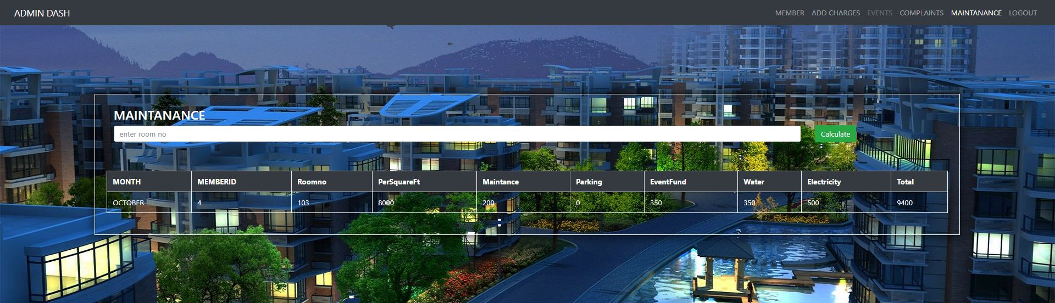

maintainance.php

<?php include("dbcon.php");?>

<html>

<head>

<title></title> <link rel="stylesheet" href="https://maxcdn.bootstrapcdn.com/bootstrap/4.0.0-beta/css/bootstrap.min.css" integrity="sha384-/Y6pD6FV/Vv2HJnA6t+vslU6fwYXjCFtcEpHbNJ0lyAFsXTsjBbfaDjzALeQsN6M" crossorigin="anonymous">

<link href="css/global.css" type="text/css" rel=" stylesheet" >

</head>

<body style="background:url('images/8.jpg') no-repeat; background-size:cover;">

<nav class="navbar navbar-expand-sm bg-dark navbar-dark">

<div class="container-fluid">

<a class="navbar-brand" href="">ADMIN DASH</a>

<nav class="nav navbar-nav">

<ul class="nav navbar-nav navbar-right">

<li class="nav-item ">

<a class="nav-link" href="admin-panel.php">MEMBER</a>

</li>

<li class="nav-item">

<a class="nav-link" href="charges.php">ADD CHARGES</a>

</li>

<li class="nav-item">

<a class="nav-link disabled" href="events.php">EVENTS</a>

</li>

<li class="nav-item">

<a class="nav-link " href="viewcomplaints.php"> COMPLAINTS</a>

</li>

<li class="nav-item active">

<a class="nav-link " href="maintanance.php"> MAINTANANCE</a>

</li>

<li class="nav-item">

<a class="nav-link " href="admin_logout.php"> LOGOUT</a>

</li>

</ul>

</nav>

</div>

</nav>

<?php

session_start();

if(isset($_SESSION['username'])) {

}

else

{

header("location: admin.php");

}

?>

<div class="container-fluid">

<div class="row">

<div class="col-md-3”>

</div>

<div class="col-md-10">

<form class="form-container" action="maintanance.php" method="POST">

<h3> MAINTANANCE</h3>

<div class="row">

<div class="col-md-10"><input type="text" name="search" class="form-control" placeholder="enter room no"><br></div>

<div class="col-md-2"><input type="submit"value=" Calculate" name="membersearch" class="btn btn-success"></div><div class="card-body"></div>

<table class="table table-striped table-hover table-bordered">

<thead>

<tr class="bg-dark text-white text-center">

<th>MONTH</th>

<th>MEMBERID</th>

<th>Roomno</th>

<th>PerSquareFt</th>

<th>Maintance</th>

<th>Parking</th>

<th>EventFund</th>

<th>Water</th>

<th>Electricity</th>

<th>Total</th>

</tr>

</thead>

<tbody>

<?php

if(isset($_POST['membersearch']))

{

$roomno=$_POST['search'];

$que="Select * from addmember where roomno='$roomno'";

$res=mysqli_query($con,$que);

$query="Select * from charges";

$result=mysqli_query($con,$query);

while (($row=mysqli_fetch_array($result))&& ($row1=mysqli_fetch_array($res))){

?><tr>

<?php

if($row1['parking']=='Yes'){

?>

<td><?php echo $row['month'] ?></td>

<td><?php echo $row1['memberid'] ?></td>

<td><?php echo $row1['roomno'] ?></td>

<td><?php echo $row['persquareft']* $row1['area'] ?></td>

<td><?php echo $row['maintanance'] ?></td>

<td><?php echo $row['parking'] ?></td>

<td><?php echo $row['eventfund'] ?></td>

<td><?php echo $row['water'] ?></td>

<td><?php echo $row['electricity'] ?></td>

<td><?php echo $row['electricity']+($row['persquareft']*$row1['area'])+$row['maintanance']+ $row['parking']+$row['eventfund']+ $row['water'] ?></td>

<?php

}

elseif($row1['parking']=='No'){

?>

<td><?php echo $row['month'] ?></td>

<td><?php echo $row1['memberid'] ?></td>

<td><?php echo $row1['roomno'] ?></td>

<td><?php echo $row['persquareft']* $row1['area'] ?></td>

<td><?php echo $row['maintanance'] ?></td>

<td><?php echo $row['parking']*0 ?></td>

<td><?php echo $row['eventfund'] ?></td>

<td><?php echo $row['water'] ?></td>

<td><?php echo $row['electricity'] ?></td>

<td><?php echo $row['electricity']+($row['persquareft']*$row1['area'])+$row['maintanance']+ $row['parking']*0+$row['eventfund']+ $row['water'] ?></td>

<?php

}

?>

<?php

}

}

?>

</tbody>

</table>

</div> </div></div>

<script src="https://ajax.googleapi.com/ajax/libs/jquery/3.2.1/jquery.min.js"></script>

<script src="https://maxcdn.bootstrapcdn.com/bootstrap/4.0.0-beta/js/bootstrap.min.js" integrity="sha384-h0AbiXch4ZDo7tp9hKZ4TsHbi047NrKGLO3SEJAg45jXxnGIfYzk4Si90RDIqNm1" crossorigin="anonymous"></script>

</body>

</html>

MEMBERS

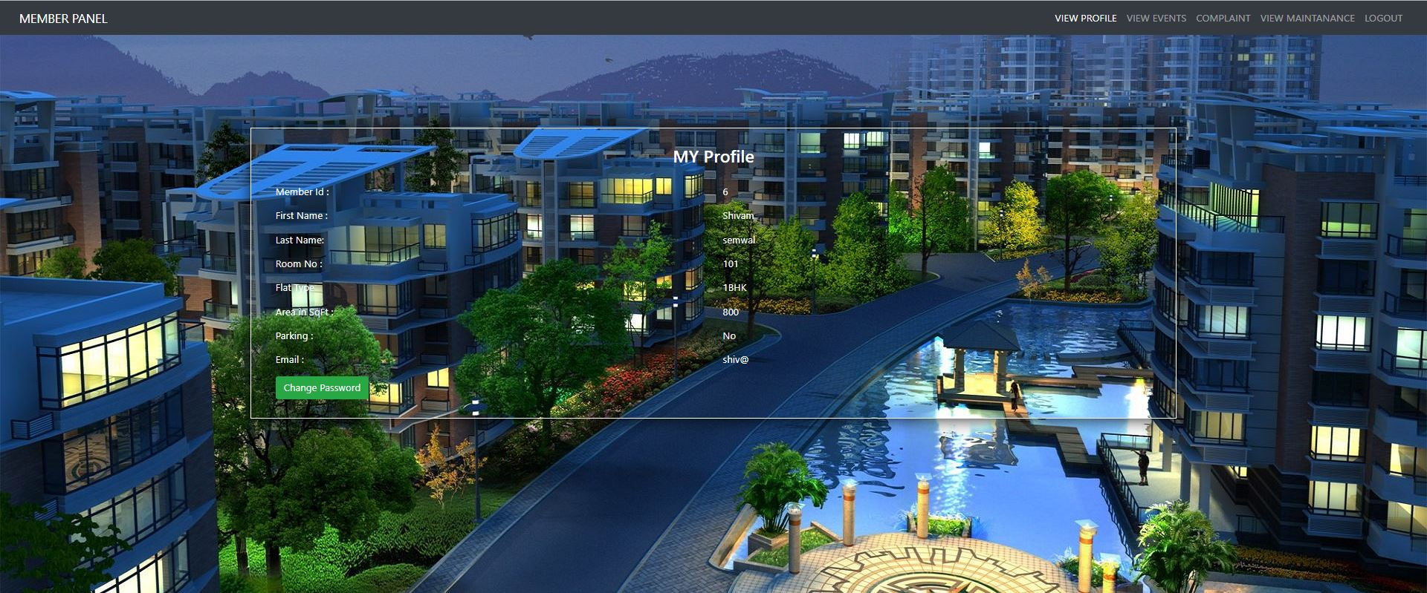

member-panel.php

<?php include("membercon.php");

?>

<html>

<head>

<title></title> <link rel="stylesheet" href="https://maxcdn.bootstrapcdn.com/bootstrap/4.0.0-beta/css/bootstrap.min.css" integrity="sha384-/Y6pD6FV/Vv2HJnA6t+vslU6fwYXjCFtcEpHbNJ0lyAFsXTsjBbfaDjzALeQsN6M" crossorigin="anonymous">

<link href="css/global.css" type="text/css" rel=" stylesheet" >

</head>

<body style="background:url('images/8.jpg') no-repeat; background-size:cover;">

<nav class="navbar navbar-expand-sm bg-dark navbar-dark">

<div class="container-fluid">

<a class="navbar-brand" href="">MEMBER PANEL</a>

<nav class="nav navbar-nav">

<ul class="nav navbar-nav navbar-right">

<li class="nav-item active">

<a class="nav-link" href="member-panel.php">VIEW PROFILE</a> </li>

<li class="nav-item">

<a class="nav-link " href="viewevents.php"> VIEW EVENTS</a> </li>

<li class="nav-item">

<a class="nav-link " href="complaints.php"> COMPLAINT</a> </li>

<li class="nav-item">

<a class="nav-link " href="mymaintanance.php">VIEW MAINTANANCE</a> </li>

<li class="nav-item">

<a class="nav-link " href="memberlogout.php"> LOGOUT</a> </li>

</ul>

</nav>

</div>

</nav>

<?php

session_start();

if(isset($_SESSION['roomno'])) {

echo "";

}

else

{

header("location: members.php");

}

?>

<div class="row">

<div class="col-md-2"></div>

<div class="col-md-8">

<div class="container-fluid">

<form class="form-container" action="changepassword.php" method="POST">

<h3 align="center"> MY Profile</h3><br>

<div class="tab-content profile-tab" id="myTabContent">

<?php

$query="Select * from addmember where roomno='{$_SESSION['roomno']} '";

$result=mysqli_query($con,$query);

while ($row=mysqli_fetch_array($result)){

?>

<div class="tab-pane fade show active" id="home" role="tabpanel" aria-labelledby="home-tab">

<div class="row">

<div class="col-md-6">

<label>Member Id :</label>

</div>

<div class="col-md-6">

<p><?php echo $row['memberid'] ?></p>

</div>

</div>

<div class="row">

<div class="col-md-6">

<label>First Name :</label>

</div>

<div class="col-md-6">

<p><?php echo $row['fname'] ?></p>

</div>

</div>

<div class="row">

<div class="col-md-6">

<label>Last Name:</label>

</div>

<div class="col-md-6">

<p><?php echo $row['lname'] ?></p>

</div>

</div>

<div class="row">

<div class="col-md-6">

<label>Room No :</label>

</div>

<div class="col-md-6">

<p><?php echo $row['roomno'] ?></p>

</div>

</div>

<div class="row">

<div class="col-md-6">

<label>Flat Type </label>

</div>

<div class="col-md-6">

<p><?php echo $row['flat_type'] ?></p>

</div>

</div>

<div class="row">

<div class="col-md-6">

<label>Area in SqFt :</label>

</div>

<div class="col-md-6">

<p><?php echo $row['area'] ?></p>

</div>

</div>

<div class="row">

<div class="col-md-6">

<label>Parking :</label>

</div>

<div class="col-md-6">

<p><?php echo $row['parking'] ?></p>

</div>

</div>

<div class="row">

<div class="col-md-6">

<label>Email :</label>

</div>

<div class="col-md-6">

<p><?php echo $row['email'] ?></p>

</div>

</div>

</div>

</div>

<input type="submit" href="changepassword.php" class="btn btn-success" name="change" value="Change Password"/>

<?php

}

?>

</div>

</div></div></div>

<script src="https://ajax.googleapi.com/ajax/libs/jquery/3.2.1/jquery.min.js"></script>

<script src="https://maxcdn.bootstrapcdn.com/bootstrap/4.0.0-beta/js/bootstrap.min.js" integrity="sha384-h0AbiXch4ZDo7tp9hKZ4TsHbi047NrKGLO3SEJAg45jXxnGIfYzk4Si90RDIqNm1" crossorigin="anonymous"></script>

</body>

</html>

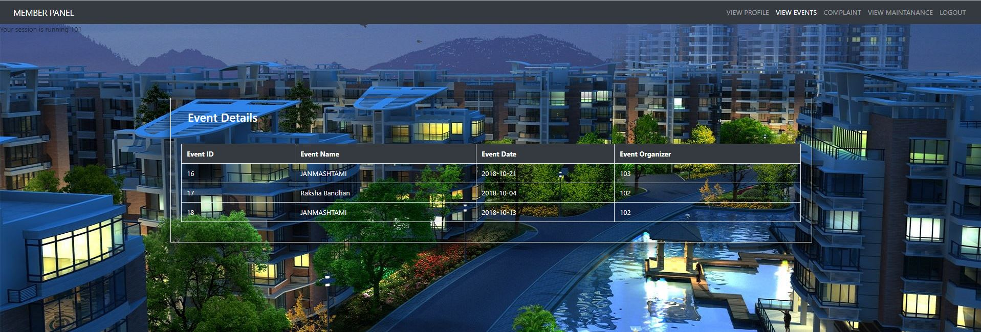

viewevents.php

<?php

include('dbcon.php');

?>

<html>

<head>

<title></title> <link rel="stylesheet" href="https://maxcdn.bootstrapcdn.com/bootstrap/4.0.0-beta/css/bootstrap.min.css" integrity="sha384-/Y6pD6FV/Vv2HJnA6t+vslU6fwYXjCFtcEpHbNJ0lyAFsXTsjBbfaDjzALeQsN6M" crossorigin="anonymous">

<link href="css/global.css" type="text/css" rel=" stylesheet" >

</head>

<body style="background:url('images/8.jpg') no-repeat; background-size:cover;">

<nav class="navbar navbar-expand-sm bg-dark navbar-dark">

<div class="container-fluid">

<a class="navbar-brand" href="">MEMBER PANEL</a>

<nav class="nav navbar-nav">

<ul class="nav navbar-nav navbar-right">

<li class="nav-item ">

<a class="nav-link" href="member-panel.php">VIEW PROFILE</a>

</li>

<li class="nav-item active">

<a class="nav-link " href="viewevents.php"> VIEW EVENTS</a>

</li>

<li class="nav-item ">

<a class="nav-link " href="complaints.php"> COMPLAINT</a>

</li>

<li class="nav-item">

<a class="nav-link " href="mymaintanance.php">VIEW MAINTANANCE</a>

</li>

<li class="nav-item">

<a class="nav-link " href="memberlogout.php"> LOGOUT</a>

</li>

</ul>

</nav>

</div>

</nav>

<?php

session_start();

if(isset($_SESSION['roomno'])) {

echo "Your session is running " . $_SESSION['roomno'];

}

else

{

header("location: members.php");

}

?>

<div class="container-fluid">

<div class="row">

<div class="col-md-2"></div>

<div class="col-md-8">

<form class="form-container" action="member_search.php" method="POST">

<h3> Event Details</h3>

<div class="row">

<div class="card-body"></div>

<table class="table table-striped table-hover table-bordered">

<thead>

<tr class="bg-dark text-white text-center">

<th>Event ID</th>

<th>Event Name</th>

<th>Event Date</th>

<th>Event Organizer</th>

</tr>

</thead>

<tbody>

<?php

$query="Select * from events ";

$result=mysqli_query($con,$query);

while ($row=mysqli_fetch_array($result)){

?><tr>

<td><?php echo $row['eid'] ?></td>

<td><?php echo $row['ename'] ?></td>

<td><?php echo $row['edate'] ?></td>

<td><?php echo $row['eorganizer'] ?></td>

</tr>

<?php

if (isset($_GET['idd'])){

$idd=$_GET['idd'];

$query="Delete from events where eid='$idd'";

$result=mysqli_query($con,$query);

if($result){

echo"<script>alert('Event deleted')</script>";

echo "<script>window.open('events.php','_self')</script>";

}

else{

echo"<script>alert('Failed')</script>";

echo "<script>window.open('events.php','_self')</script>";

}

}

?>

<?php

}

?>

</tbody></table>

</div></div>

<script src="https://ajax.googleapi.com/ajax/libs/jquery/3.2.1/jquery.min.js"></script>

<script src="https://maxcdn.bootstrapcdn.com/bootstrap/4.0.0-beta/js/bootstrap.min.js" integrity="sha384-h0AbiXch4ZDo7tp9hKZ4TsHbi047NrKGLO3SEJAg45jXxnGIfYzk4Si90RDIqNm1" crossorigin="anonymous"></script>

</body>

</html>

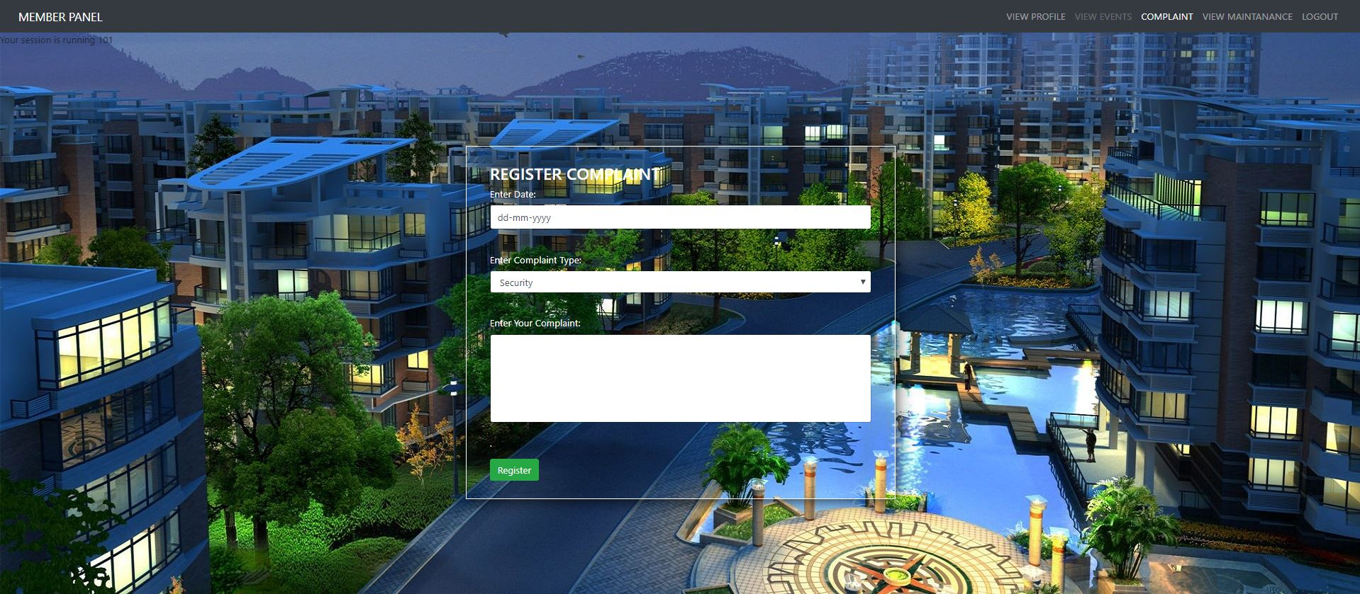

complaints.php

<?php include("dbcon.php");?>

<html>

<head>

<title></title> <link rel="stylesheet" href="https://maxcdn.bootstrapcdn.com/bootstrap/4.0.0-beta/css/bootstrap.min.css" integrity="sha384-/Y6pD6FV/Vv2HJnA6t+vslU6fwYXjCFtcEpHbNJ0lyAFsXTsjBbfaDjzALeQsN6M" crossorigin="anonymous">

<link href="css/global.css" type="text/css" rel=" stylesheet" >

</head>

<body style="background:url('images/8.jpg') no-repeat; background-size:cover;">

<nav class="navbar navbar-expand-sm bg-dark navbar-dark">

<div class="container-fluid">

<a class="navbar-brand" href="">MEMBER PANEL</a>

<nav class="nav navbar-nav">

<ul class="nav navbar-nav navbar-right">

<li class="nav-item ">

<a class="nav-link" href="member-panel.php">VIEW PROFILE</a></li>

<li class="nav-item">

<a class="nav-link disabled" href="viewevents.php"> VIEW EVENTS</a> </li>

<li class="nav-item active">

<a class="nav-link " href="complaints.php"> COMPLAINT</a>

</li>

<li class="nav-item">

<a class="nav-link " href="mymaintanance.php">VIEW MAINTANANCE</a>

</li>

<li class="nav-item">

<a class="nav-link " href="memberlogout.php"> LOGOUT</a>

</li> </ul>

</nav> </div></nav>

<?php

session_start();

if(isset($_SESSION['roomno'])) {

echo "Your session is running " . $_SESSION['roomno'];

}

else {

header("location: members.php");

}

?>

<div class="container-fluid">

<div class="row">

<div class="col-md-4"></div>

<div class="col-md-4">

<div class="row">

<div class="card-body" >

<form class="form-container" action="membercon.php" method="POST">

<h3 > REGISTER COMPLAINT</h3>

<div class="form-group">

<label>Enter Date:</label>

<input type="date" name="cdate" class="form-control" required><br>

</div>

<div class="form-group">

<label>Enter Complaint Type:</label>

<select name ="type"class ="form-control">

<option name="type1" value="Security">Security</option>

<option name="type2" value="Cleanliness">Cleanliness</option>

<option name="type3" value="Parking">Parking</option>

<option name="type4" value="Water">Water</option>

<option name="type5" value="Electricity">Electricity</option>

<option name="type6" value="Other">Other</option>

</select><br>

</div>

<div class="form-group">

<label>Enter Your Complaint:</label>

<input type="text" style=" height:150px;" name="cdescription" class="form-control" required> <br>

</div>

<input type="submit" name="csubmit" value="Register" class="btn btn-success"> <br>

</form>

</div> </div></div>

<script src="https://ajax.googleapi.com/ajax/libs/jquery/3.2.1/jquery.min.js"></script>

<script src="https://maxcdn.bootstrapcdn.com/bootstrap/4.0.0-beta/js/bootstrap.min.js" integrity="sha384-h0AbiXch4ZDo7tp9hKZ4TsHbi047NrKGLO3SEJAg45jXxnGIfYzk4Si90RDIqNm1" crossorigin="anonymous"></script>

</body>

</html>

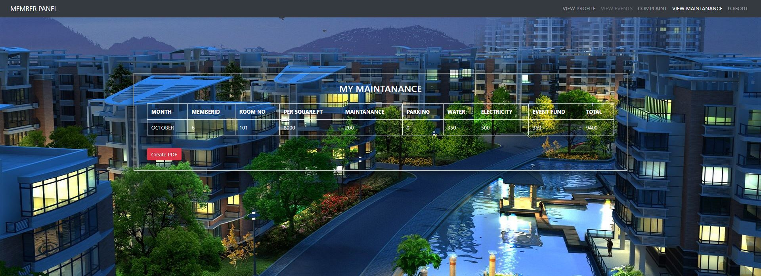

mymaintanance.php

<?php

session_start();

if(!isset($_SESSION['roomno']))

{

header("location:members.php");

}

function fetch_data()

{

$output = '';

$connect = mysqli_connect("localhost", "root", "", "my");

$sql = "SELECT * FROM addmember where roomno='{$_SESSION['roomno']}'";

$result = mysqli_query($connect, $sql);

$sql1 = "SELECT * FROM charges";

$result1 = mysqli_query($connect, $sql1);

while(($row = mysqli_fetch_array($result)) && ($row1 = mysqli_fetch_array($result1)))

{

if($row['parking']=='Yes')

{

$output .= '<tr>

<td>'.$row1["month"].'</td>

<td>'.$row["memberid"].'</td>

<td>'.$row["roomno"].'</td>

<td>'.$row1["persquareft"]*$row["area"].'</td>

<td>'.$row1["maintanance"].'</td>

<td>'.$row1["parking"].'</td>

<td>'.$row1["water"].'</td>

<td>'.$row1["electricity"].'</td>

<td>'.$row1["eventfund"].'</td>

<td>'.($row1["persquareft"]*$row["area"] + $row1["water"] + $row1["parking"] + $row1["electricity"] + $row1["eventfund"] + $row1["maintanance"]).'</td>

</tr>

';

}

elseif($row['parking']=='No')

{

$output .= '<tr>

<td>'.$row1["month"].'</td>

<td>'.$row["memberid"].'</td>

<td>'.$row["roomno"].'</td>

<td>'.$row1["persquareft"]*$row["area"].'</td>

<td>'.$row1["maintanance"].'</td>

<td>'.$row1["parking"]*0 .'</td>

<td>'.$row1["water"].'</td>

<td>'.$row1["electricity"].'</td>

<td>'.$row1["eventfund"].'</td>

<td>'.($row1["persquareft"]*$row["area"] + $row1["water"] + $row1["parking"]*0 + $row1["electricity"] + $row1["eventfund"] + $row1["maintanance"]).'</td>

</tr>

';

}

}

return $output;

}

if(isset($_POST["create_pdf"]))

{

require_once('tcpdf/tcpdf.php');

$obj_pdf = new TCPDF('P', PDF_UNIT, array(400, 352), true, 'UTF-8', false);

$obj_pdf->SetCreator(PDF_CREATOR);

$obj_pdf->SetTitle("MY HOUSING SOCIETY BILL");

$obj_pdf->SetHeaderData('', '', PDF_HEADER_TITLE, PDF_HEADER_STRING);

$obj_pdf->setHeaderFont(Array(PDF_FONT_NAME_MAIN, '', PDF_FONT_SIZE_MAIN));

$obj_pdf->setFooterFont(Array(PDF_FONT_NAME_DATA, '', PDF_FONT_SIZE_DATA));

$obj_pdf->SetDefaultMonospacedFont('helvetica');

$obj_pdf->SetFooterMargin(PDF_MARGIN_FOOTER);

$obj_pdf->SetMargins(PDF_MARGIN_LEFT, '5', PDF_MARGIN_RIGHT);

$obj_pdf->setPrintHeader(false);

$obj_pdf->setPrintFooter(false);

$obj_pdf->SetAutoPageBreak(TRUE, 10);

$obj_pdf->SetFont('helvetica', '', 12);

$obj_pdf->AddPage();

$content = '';

$content .= '

<h3 align="center">MY HOUSING SOCIETY</h3><br><br>

<table border="1" cellspacing="0" cellpadding="5">

<tr>

<th>MONTH</th>

<th>MEMBERID</th>

<th>ROOM NO</th>

<th>PER SQUARE FT</th>

<th>MAINTANANCE</th>

<th>PARKING</th>

<th>WATER</th>

<th>ELECTRICITY</th>

<th>EVENT FUND</th>

<th>TOTAL</th>

</tr>

';

$content .= fetch_data();

$content .= '</table>';

$obj_pdf->writeHTML($content);

$obj_pdf->Output('sample.pdf', 'I');

}

?>

<!DOCTYPE html>

<html>

<head>

<title></title>

<link rel="stylesheet" href="https://maxcdn.bootstrapcdn.com/bootstrap/4.0.0-beta/css/bootstrap.min.css" integrity="sha384-/Y6pD6FV/Vv2HJnA6t+vslU6fwYXjCFtcEpHbNJ0lyAFsXTsjBbfaDjzALeQsN6M" crossorigin="anonymous">

<link href="css/global.css" type="text/css" rel=" stylesheet" >

</head>

<body style="background:url('images/8.jpg') no-repeat; background-size:cover;">

<nav class="navbar navbar-expand-sm bg-dark navbar-dark">

<div class="container-fluid">

<a class="navbar-brand" href="">MEMBER PANEL</a>

<nav class="nav navbar-nav">

<ul class="nav navbar-nav navbar-right">

<li class="nav-item ">

<a class="nav-link" href="member-panel.php">VIEW PROFILE</a>

</li>

<li class="nav-item">

<a class="nav-link disabled" href="viewevents.php"> VIEW EVENTS</a>

</li>

<li class="nav-item ">

<a class="nav-link " href="complaints.php"> COMPLAINT</a>

</li>

<li class="nav-item active">

<a class="nav-link " href="mymaintanance.php">VIEW MAINTANANCE</a>

</li>

<li class="nav-item">

<a class="nav-link " href="memberlogout.php"> LOGOUT</a>

</li>

</ul>

</nav>

</div>

</nav>

<div class="container-fluid">

<div class="row">

<div class="col-md-2"></div>

<div class="col-md-8">

<div class="row">

<div class="card-body" >

<form class="form-container" action="" method="POST">

<h3 align="center">MY MAINTANANCE</h3><br />

<div class="table-responsive">

<table class="table table-bordered">

<tr>

<th>MONTH</th>

<th>MEMBERID</th>

<th>ROOM NO</th>

<th>PER SQUARE FT</th>

<th>MAINTANANCE</th>

<th>PARKING</th>

<th>WATER</th>

<th>ELECTRICITY</th>

<th>EVENT FUND</th>

<th>TOTAL</th>

</tr>

<?php

echo fetch_data();

?>

</table>

<br />

<form method="post">

<input type="submit" name="create_pdf" class="btn btn-danger" value="Create PDF" />

</form>

</div>

</div>

</div>

</div>

</div>

</body>

</html>

BILL REPORT

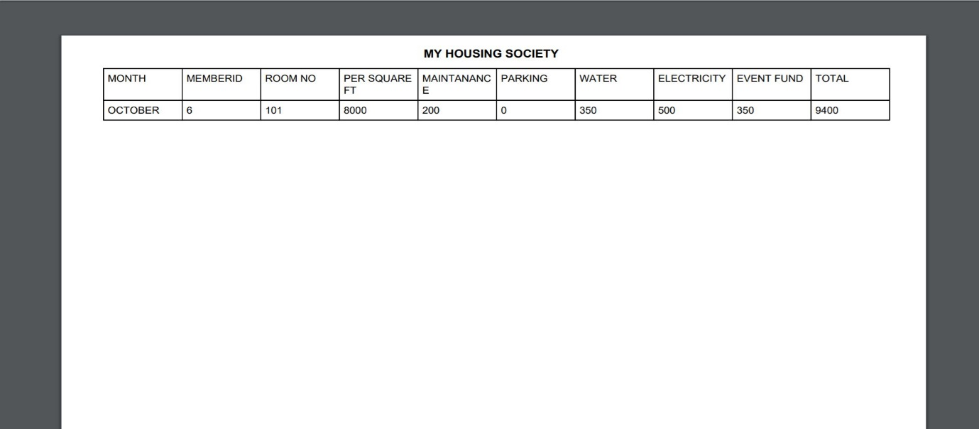

**FUTURE ENHANCEMENTS**

1.A system for sending emails and a chat system could be added for communication between different members of the society.

2.Online payments of bills can be added to the system to make it more comfortable to the members and the society

3.A voting system could be added to select various positions in the society like Secretary, Chairperson , Treasurer etc.

4. A mobile application of the same could be developed.

**REFERENCES AND BIBLIOGRAPHY**

References:

* www.youtube.com
* http://stackoverflow.com/
* www.w3schools.com
* http://php.net/manual/en/index.php